Data Analytics

D Samanta

Topic 3:

The given attributes are as follows:

|  |  |  |  |  |  |
| --- | --- | --- | --- | --- | --- |
| SN | Attributes | Classification | SN | Attributes | Classification |
| 1 | Symboling | Nominal | 14 | Height | Interval |
| 2 | Normalized.losses | Interval | 15 | Curb.weight | Interval |
| 3 | Make | Nominal | 16 | Engine.type | Nominal |
| 4 | Fuel.type | Nominal | 17 | Num.of.cylinders | Ordinal |
| 5 | Aspiration | Nominal | 18 | Engine.size | Interval |
| 6 | Num.of.doors | Ordinal | 19 | Fuel.system | Nominal |
| 7 | Body.style | Nominal | 20 | Bore | Interval |
| 8 | Drive.wheels | Nominal | 21 | Stroke | Interval |
| 9 | Engine.location | Nominal | 22 | Compression.ratio | Ratio |
| 10 | Wheel.base | Interval | 23 | Horsepower | Interval |
| 11 | Length | Interval | 24 | Peak.rpm | Interval |
| 12 | Width | Interval | 25 | City.mpg | Interval |
| 13 | Highway.mpg | Interval | 26 | price | Ratio |

Now we are required to apply the applicable central tendency measures to any four attributes taking one attribute from each category.

For this purpose, we are choosing the following attributes and calculated the randomly chosen central tendency. These are as following:

Mode of the Number of Cylinders = Four

Mode of Body Style of the automobiles = Sedan

Median of the height = 54.1

Mean of the Compression Ration = 10.14

Now histogram of peak-rpm and city-mpg was drawn so evaluate the distributions.

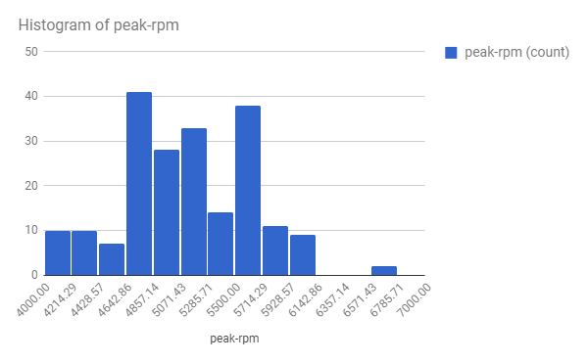

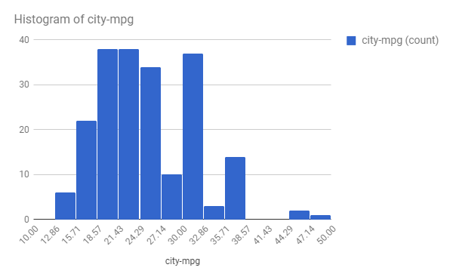

After analyzing the graph it is clear that peak-rpm is normally distributed whereas city-mpg is positively skewed distribution.